Application Form * If you wish to apply more than one artwork, be sure to submit an application form for each of the artworks.
Details of Applicant (contact information) *Results will be mailed to this address.
Applicant’s name
 | For organizations or groups: fill in the name of institution, and the person in charge.
Relationship to artist
[1] Artist responsible for creating the artwork [2] Person with parental responsibilities and rights (for a minor)
[3] Artist’s legal guardian [4] Juridical person entrusted with rights to the entered artwork
Address
Phone/Fax numbers | Phone |  | Fax
Email
Details of Artist
Artist’s name | Name |  | Pen name *If you choose to use one.
Date of Birth | month / date / year | Age | Country of residence
Disability type
About the Artist（profile, history of creative activities, etc.）

Office use only

Details of the Artwork for Entry
Title |  |  |  |  | Year Created
Type  Select the item that  applies to the artwork. | Painting or drawing (including Illustration, Computer graphics (printed out))  Calligraphic artwork Photography Three-dimensional artwork  Others (Please specify):
Size and weight | A. Length/ height  cm | B. Width  cm | C. Depth  (If three-dimensional)  cm | D. Weight  (If three-dimensional)  kg
Material  (support medium,  printing method, etc.) | Examples: <painting> acrylic and crayon on canvas <Calligraphic artwork> ink, xuan paper, <Photo> digital print  <three-dimensional> paper clay, glue, cardboard
About the artwork for entry (The points you want to call attention to; the background of its creation, etc.)
* The information in this form may be published in the catalog or in the exhibition of the Selected Works if your artwork wins any awards.
Name of the person who filled out the form [ ] (In case anyone other than the artist did.)

UP
DOWN
DOWN
UP | 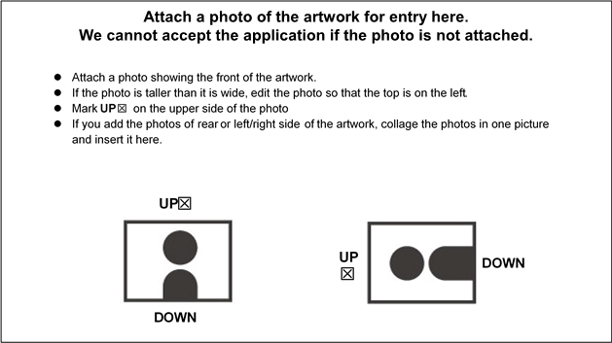
Click the icon in the center to insert the image of your artwork.

