* Complete a separate application form for each artwork, and keep their photocopies in a safe place without fail.
Application Form
The application forms will not be returned.
Details of Applicant * Results will be mailed to this address.
Applicant’s name
 | In the case the applicant is an organization, please provide the corporate name (institution name or school name) and the name of the person in charge
Relationship with artist (check one box ☒)
[1] Artist responsible for creating the artwork [2] Person with parental authority (in the case where the artist is a minor) [3] Guardian [4] Juridical person entrusted with the right to use the entered artwork
Address
Phone / Fax / Email | Phone |  | Fax
 | Email
Details of Artist
Artist’s name | Name |  | Pen name * Fill in only if a pen name is used
Date of Birth | month / date / year | Age | Country of residence
Disability type
About the Artist (profile, history of creative activities, etc.)
This space is for the use of office staff
* This space is used for processing applications and screening, so do not write in this space.
Details of the Artwork for Entry
Title |  |  |  | Year Created
Classification of artwork  (Check all boxes that apply☒) | Painting (includes illustration, graphic design, print)  Calligraphy Photograph Three-dimensional artwork  Other:
Size and weight | A. Height  cm | B. Width  cm | C. Depth  * If three-dimensional  cm | D. Weight  * If three-dimensional  kg
Materials  (Support medium,  printing method, etc.) | Examples: <Painting> acrylic and crayon on canvas <Calligraphy> ink, xuan paper <Photograph> digital print  <Three-dimensional> paper clay, glue, cardboard
About the artwork (particular PR point of the artwork, the circumstances at the time it was created, etc.)
* Should the artwork be selected for an award, the contents of “About the artwork” may appear in the Catalog of Selected Artworks and be exhibited at the Exhibition of Selected Artworks.
Name of person filling in this section[ ](in case someone other than the artist is filling in the form)
UP
DOWN
DOWN
UP | 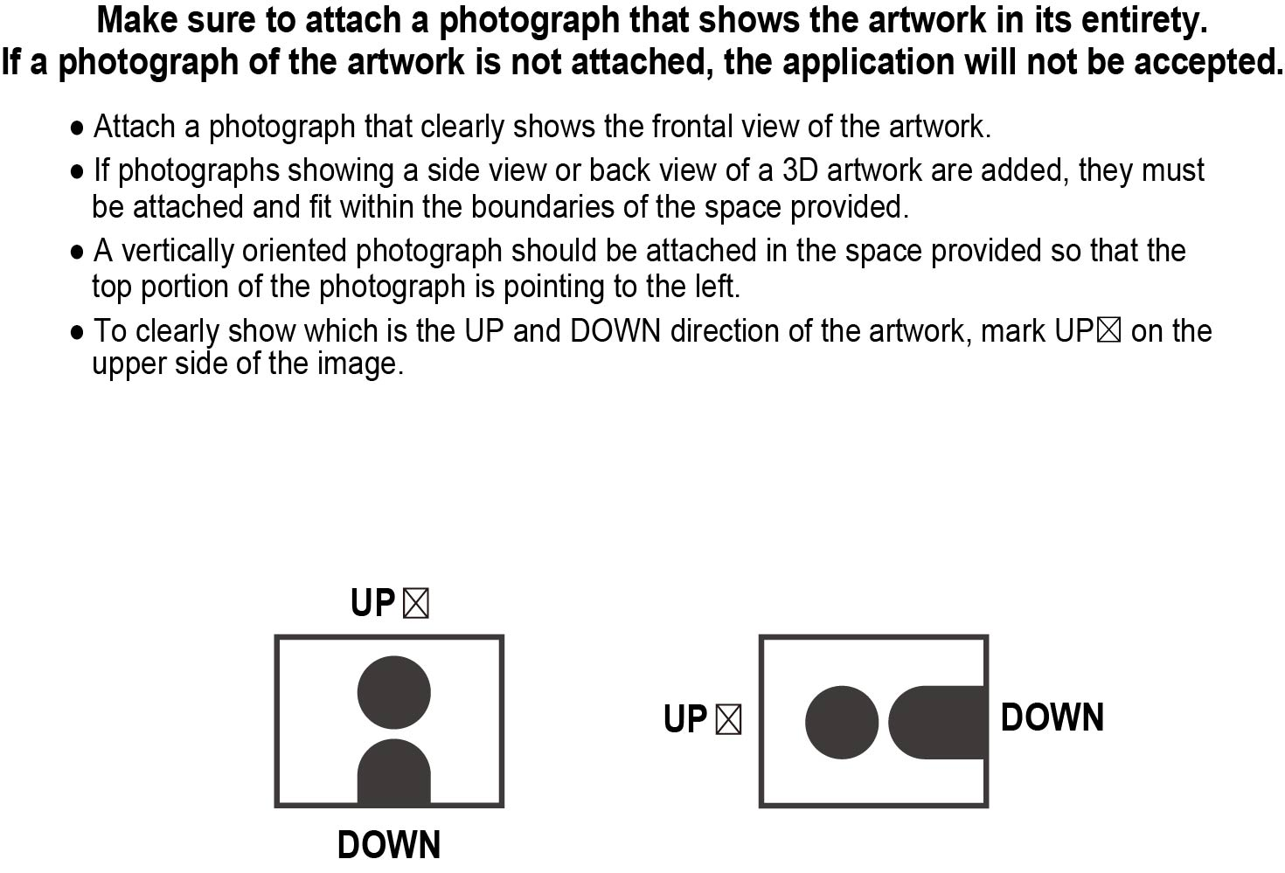
Upload the image of the artwork by clicking on the center icon.

